Workaround Procedure: Re-open Review for Missing Reviewer File Upload
NPRE / EM - Reviewer file upload workaround

Purpose | Provide a clear workaround when a reviewer missed uploading a file during the review stage.
Issue observed | The Editor cannot upload reviewer files in NPRE.  JM/APS users also do not currently have access to upload files on behalf of the reviewer once the review has been completed.  - If the status still shows “Under Review”, we can proceed with the suggested workaround (reopen the review).  - If the status has moved to “Decision in progress” or a decision has already been taken, then reach out to the Editor first (since decision-making may have already started).
Workaround | Re-open the review so the reviewer status changes to Partial Review Saved. The reviewer can then access NPRE again, edit comments if required, and upload the missed file.
Users involved | Editor / Journal Manager / APS / Reviewer

Important note
Use this workaround only when the reviewer has completed the review but missed uploading the required file. Re-opening the review allows the reviewer to return to NPRE and upload the file.

Step-by-step procedure

Step 1: Search for the manuscript in EM.
Open the manuscript record and go to the Action menu> select “Invite Reviewers”
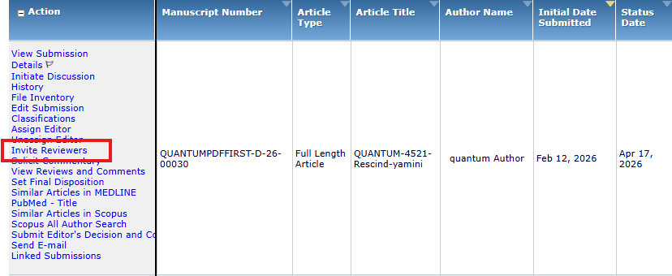
Screenshot 1: Action menu with Invite Reviewers option.

Step 2: In the Invite Reviewers menu

Find “View Reviews and Comments”
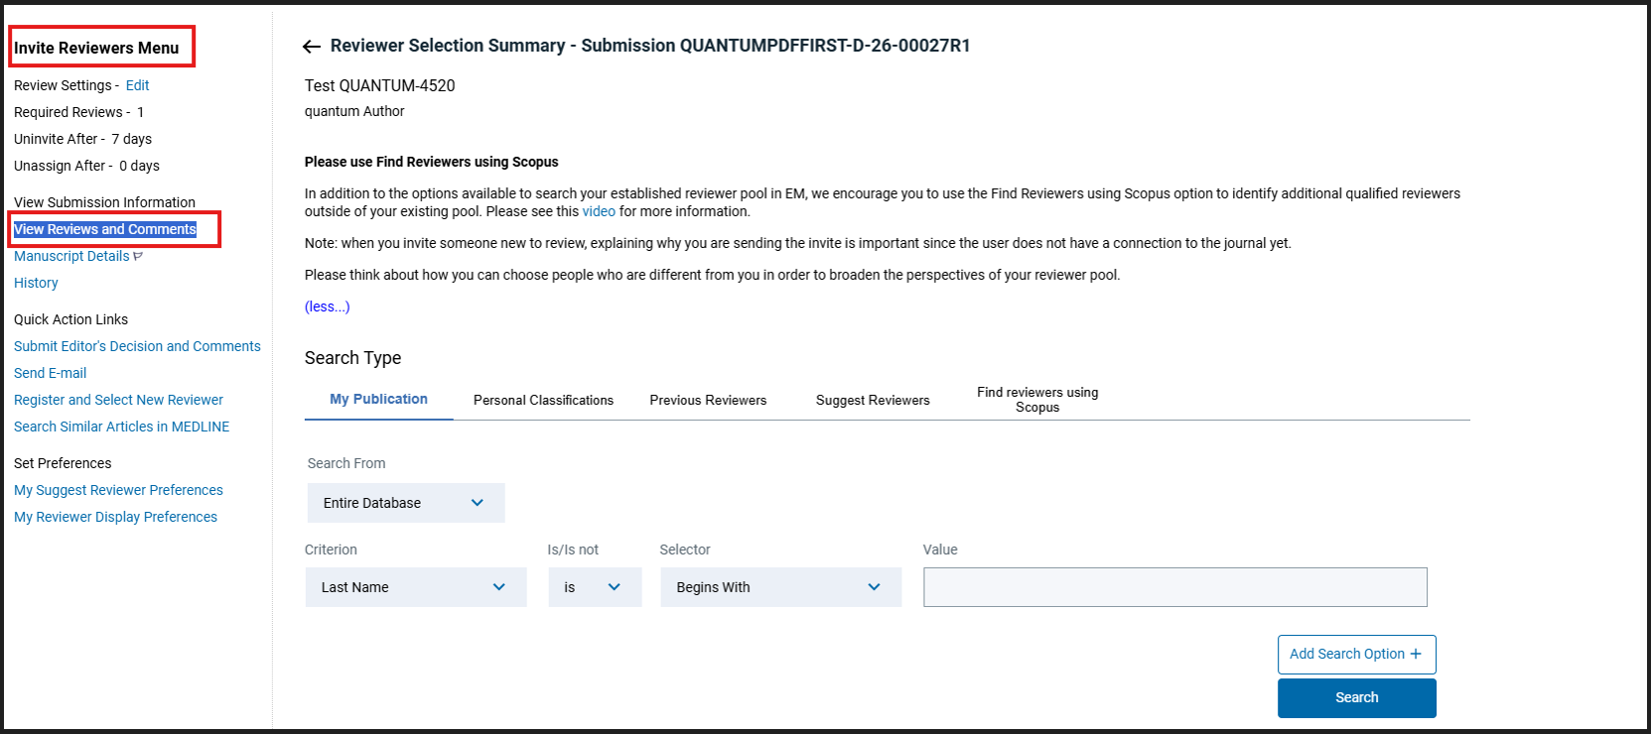
Screenshot 2: Invite Reviewers menu and View Reviews and Comments option.

Step 3: Open View Reviews and Comments.
- On the left-side menu, click View Reviews and Comments.
- Select the completed reviewer decision.
- In the reviewer list, identify the reviewer who completed the review. Click the reviewer decision link, for example Reject.

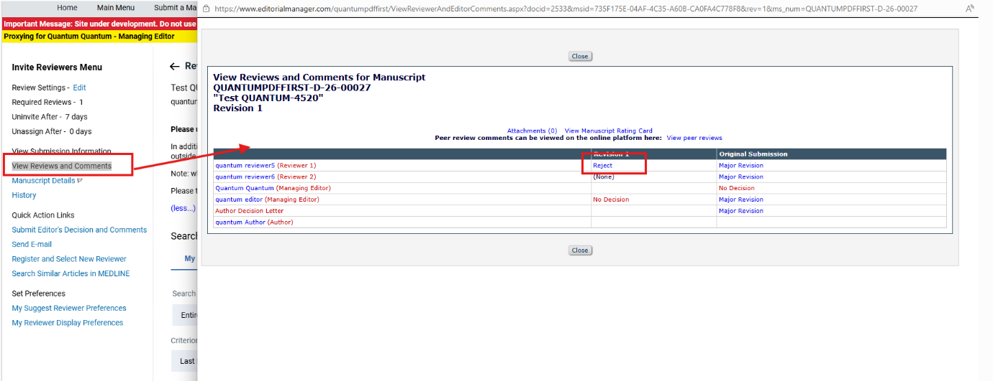
Screenshot 3: Completed reviewer decision link, for example Reject.

Step 4: Re-open the review.
On the reviewer’s decision screen, click Re-open Review.

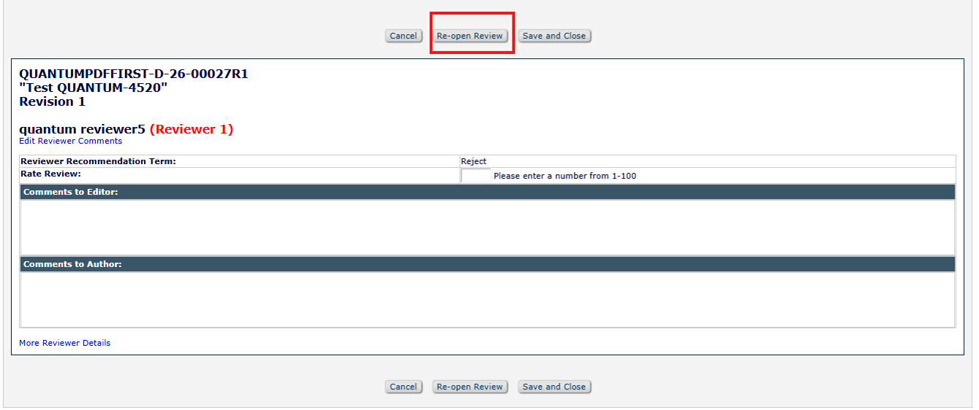
Screenshot 4: Re-open Review button on the reviewer decision screen.

Step 5: Confirm the warning message.
A warning pop-up will appear asking whether you are sure you want to re-open the review. Click OK.
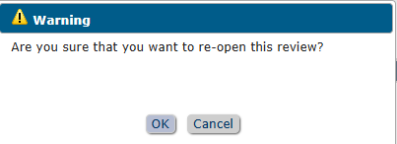
Screenshot 5: Warning message displayed before re-opening the review.

Step 6: Verify the re-open confirmation.
The system displays confirmation that the email has been sent to the reviewer.
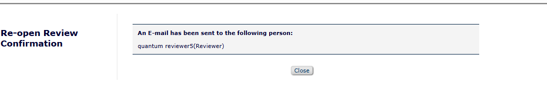
Screenshot 6: Re-open review email confirmation.

Step 7: Confirm the reviewer status.
Return to View Reviews and Comments and confirm the reviewer status has changed to Partial Review Saved.
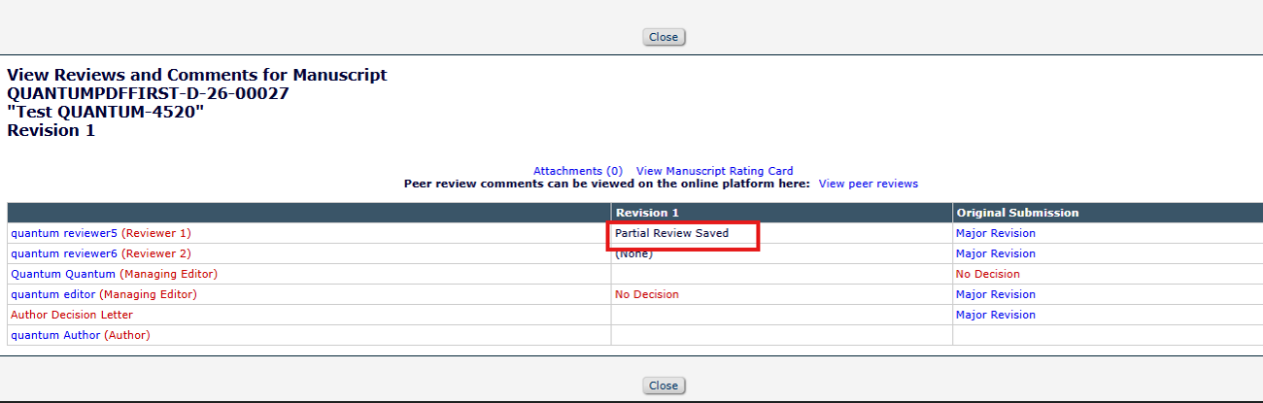
Screenshot 7: Reviewer status changed to Partial Review Saved.

Step 8: Reviewer uploads the missed file in NPRE.
The reviewer can now access NPRE again, edit the comments if required, and upload the missing file using the Upload a file option.
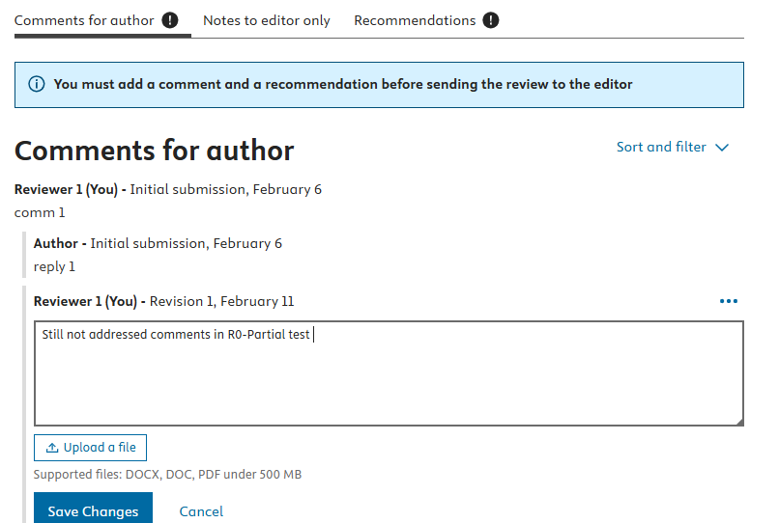
Screenshot 8: NPRE screen where the reviewer can upload the file.

Expected outcome
The review is successfully re-opened, the reviewer status changes to Partial Review Saved, and the reviewer can access NPRE again to upload the missing file. Once the reviewer uploads the file and completes the review again, the Editor can continue with the decision process.

Reminder
JM/APS/Editor users cannot upload the missed file on behalf of the reviewer during the Decision stage. The review must be re-opened so the reviewer can upload the file directly to NPRE.

